Smart Solar Grass Cutter With Lawn Coverage
The smart grass cutter system puts forth a completely automated lawn mower mechanism. The robotic vehicle is equipped with a grass cutter blade that allows for grass cutting at high RPM. The system has a smart functionality that allows it to cover the complete area of a lawn or garden by detecting corners using ultrasonic sensor and moving in a zigzag manner in order to cover the entire area. This efficient system uses a microcontroller based circuit in order to achieve this functionality. It is a battery operated system that uses 2 batteries. One battery is used to run the vehicle movement DC motors and the other one is used to power the grass cutter motor. Also the system uses a solar panel to demonstrate the charging of vehicle movement battery. The microcontroller operates the vehicle movement dc motors as well as the grass cutter at the same time as monitoring the ultrasonic sensors. The microcontroller smartly operates the dc motors using the motor driver IC to achieve desired movement based on ultrasonic inputs. The system also uses a gyro sensor in order to achieve perfect 180 degree turns in order to achieve complete lawn/garden coverage. Thus this system allows for fully automated grass cutting system without the need for any human intervention.
Block Diagram:
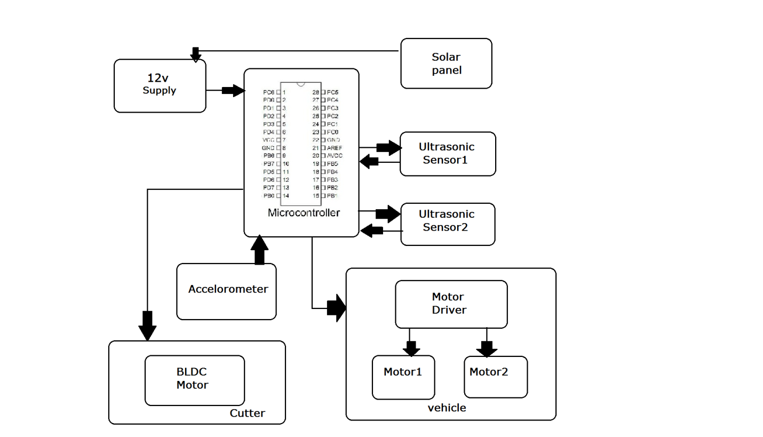

Hardware Specifications
- Solar Panel
- Atmega 328 Microcontroller
- DC motors
- Ultrasonic Sensors
- Accelerometer/Gyro
- BLDC Motor
- Transformer
- Registers
- Capacitors
- Diodes

Software Specifications
- Arduino Compiler
- MC Programming Language: C

